**Islamabad:**

Pir Sohawa

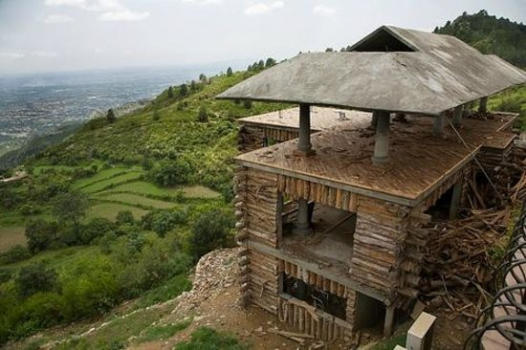

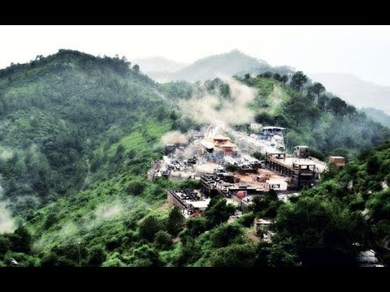

**Pir Sohawa** is a rapidly developing tourist resort located 17 kilometers (11mi) from Islamabad on top of Margalla Hills. It has a 3000 plus ft elevation and located in Monal village which is geographically part of Haripur District. On 6 January 2012, after almost six years, Pir Sohawa, the city’s highest tourist spot, received few inches of snowfall. Bright hills is a holiday resorts at scenic views of canyons on Margalla hills at 4800 feet above sea level. 22 km from zoo islamabad.